David Barney
Prof. Trisha Bailey
Eng. 2010
February 20 2012
What You May Not Know About Alcohol
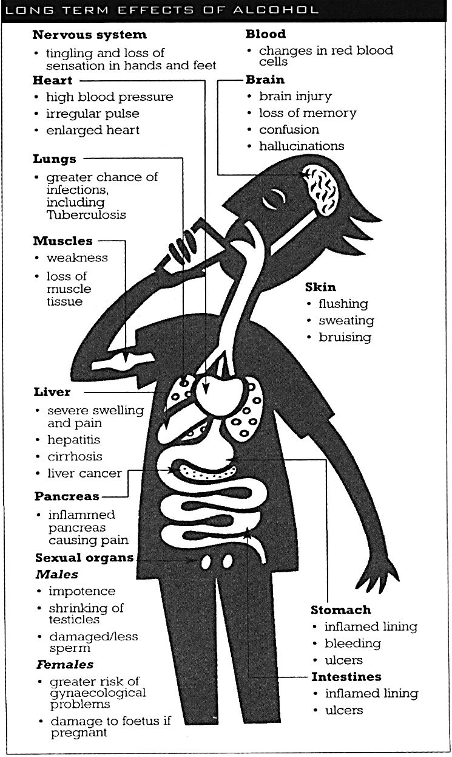
Introduction:
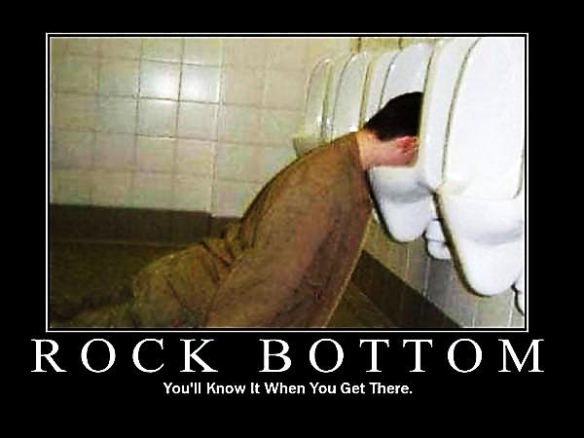
“Alcohol has been used medicinally throughout recorded history; its medicinal properties are mentioned 191 times in the Old and New Testaments” (Hanson). There are many well researched studies on the detrimental effects that alcohol can have on the human body when alcohol is abused. These effects can be both short term and long term depending on the amount consumed and length of time spent consuming—usually abuse over several years. Some of the health risks are shown in the diagram on the left. While abuse is a problem, control can offer potential health benefits when alcohol is consumed moderately. Drinking in moderation is having no more than one to two drinks per day for women and no more than two to three drinks per day for men. The body’s composition, muscle mass to healthy body fat ratios, size, and amount of water in the body differ greatly between men and women. More than a couple of drinks per day and drinking on consecutive days is considered heavy drinking or alcohol abuse. These definitions are generic and not specific to any one individual, as individual bodies and ages vary greatly. Consider drinking moderately during a meal. Over drinking can cause serious health problems, however new studies are showing that drinking moderately can have some health benefits.
www.sac.edu
http://addictionrecoveryhope.com/archives
What you may experience
Alcohol is depressant small doses can have a relaxing effect reduce tension, and lowers inhibitions. This could be the main reason why people pick up a drink.
The drinker experiences mild euphoria and loss of inhibition as alcohol impairs regions of the brain controlling behavior and emotion. Alcohol impairs judgment, memory, concentration and co-ordination. Impaired visual ability, an altered sense of time and space, Impaired fine motor skills, Loss of pain perception, unclear hearing, Slows reactions, Dulled smell and taste, and impaired sexual performance (Alcohol Prevention Education).
Alcohol effects on a developing brain
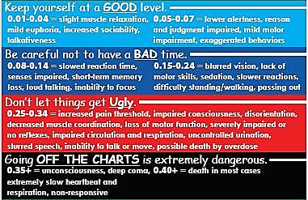
A study by the National Institute of Alcohol Abuse and Alcoholism showed that a single, moderate dose of alcohol can disrupt learning more powerfully in people in their early twenties, compared with those in their late twenties. The various effects of the consumption of alcohol during brain development can have long lasting consequences. “Studies in humans have detected cognitive impairments in adolescent alcohol abusers weeks after they stopped drinking, and a different pattern of brain response to tests of memory than among non-abusers. Research using imaging techniques to study brain structure in humans has found adolescent-onset alcohol abuse to be associated with a reduction in the size of the hippocampus” (National Institute of Alcohol Abuse and Alcoholism). The human brain continues to develop until the mid-twenties. Heavy and extended alcohol use was associated with a 10% smaller hippocampus resulting in a decrease in memory function. This information is gathered from several sources.
socialnorms.msu.edu
Alcohol effects on both men and women prior to conception.

Your sex life can be damaged by drinking alcohol. Alcohol depresses nerve impulses. Sexual function can be impaired, resulting in impotence and infertility—this can sometimes be irreversible.
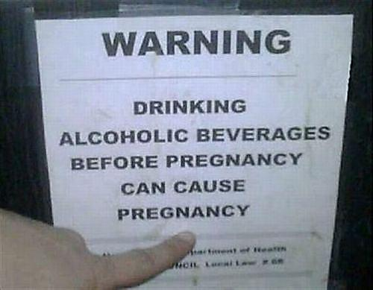
It takes about two and a half months to develop normal healthy sperm cells. It is not clear on how much alcohol can result in abnormal sperm, or what effects male alcohol use prior to conception can have on a developing fetus. “Alcohol consumption has been linked to the production of abnormal sperm cells with deformed heads and tails. Abnormal sperm are less likely to be able to fertilize an egg and more likely to create a non-viable embryo, which may result in early pregnancy loss” (Alcohol and Sperm). Few studies have been done on the possible birth defects associated with male alcohol use. It is best to abstain from alcohol if you are trying to become pregnant—yes, men too.
www.inquisitr.com

Drinking alcohol can result in an increase in sexual encounters and while alcohol can significantly decrease the chances of getting pregnant. A concern of many women about the effects of alcohol at the time of conception and up to the time when actually finding out that they are pregnant. “The fertilized egg is not dependent upon the mother for nutrition until the time of implantation, which occurs seven to ten days after ovulation. Until implantation—after which an organ called the placenta allows the transfer of nutrients, oxygen, and toxins to the fetus—there is no physical connection between mother and baby” (Hendrickson). Theoretically the toxins in the mother are unable to damage a fertilized egg. There on not a lot of controlled studies about potential effects at the time of conception. Who would want to volunteer for a study of this nature? Some information suggests that “women who consumed alcohol increased their risk of spontaneous abortion by two to three times, while men who consumed alcohol, increased their partner's risk of spontaneous abortion by two to five times” (Alcohol Prevention Education). If trying to get pregnant or if you think you may be pregnant avoid all teratogens including alcohol.
Possible benefits from moderate drinking
Studies within the last couple of decades have shown significant benefits to modest alcohol use. Drinking in moderation (as stated previously) is having no more than one to two drinks per day for women and no more than two to three drinks per day for men. “Numerous well-designed studies have concluded that moderate drinking is associated with improved health, the lowest mortality occurs in those who consume one or two drinks per day” (National Institute of Alcohol Abuse and Alcoholism).
Light drinkers tend to lead happier healthier lives, spend less time receiving medical care, and suffering less mental distress across their lifetime—vs. heavy drinkers or those who abstain from drinking. “Moderate drinkers tend to have better health and live longer than those who are either abstainers or heavy drinkers. In addition to having fewer heart attacks and strokes, moderate consumers of alcoholic beverages are generally less likely to suffer strokes, diabetes, arthritis, enlarged prostate, dementia, and several major cancers” (Hanson). Our health deteriorates as we age, it is apparent that sensible drinking and exercise slow down this process. Exercising alone does not replace the benefits of drinking. “Moderate drinking and exercise are cumulative in their positive effects on the cardiovascular system. Doing one is better than nothing, but doing both is the best choice of all and dramatically reduces the risk death from heart attack. The same is also found for all-causes of mortality” (Hanson). Alcohol contains calories, but drinking alcohol doesn't lead to weight gain according to medical research, and many studies report a small reduction in weight for women who drink.
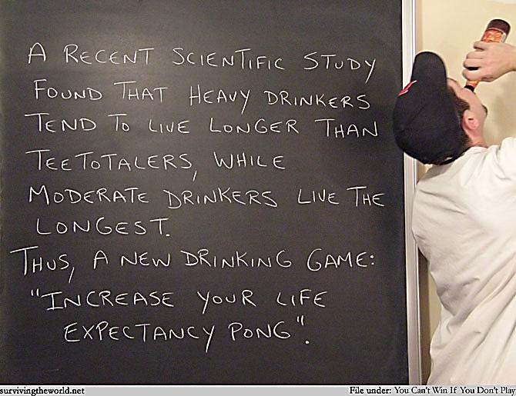
Conclusion
There are clear and proven risks to alcohol abuse, across the many stages of human development. There are several health risks throughout adulthood and alcohol can severely affect the ability to conceive as well as the development of the fetus. Some effects of alcohol abuse cause immediate risks to an individual while under the influence. An overuse of alcohol inhibits cognitive functions and can lead to a long list of very poor choices that may affect the user’s entire life, other people’s lives, or may result in death. While most alcohol abuse is considered as several drinks daily and over a period of several years, some serious problems can occur from just one night of binge drinking.
Abusing alcohol can be detrimental to one’s health, while light controlled drinking may provide some healthy rewards. Several studies are showing that light use of alcohol can have positive effects on adults. Used only in moderation, alcohol can help lead to a long and healthy life. Moderation is an average of two standard drinks per day. A standard alcoholic drink is:
- A 12-ounce can or bottle of regular beer
- A 5-ounce glass of dinner wine
- A shot (one and one-half ounces) of 80 proof liquor or spirits such as vodka, tequila, or rum either straight or in a mixed drink.
Moderate drinking and exercise go hand in hand with a strong and healthy body. “Doing one is better than nothing, but doing both is the best choice of all and dramatically reduces the risk death from heart attack” (Hanson).
Children who grow up in a household with parents that are controlled responsible drinkers are less likely to use and abuse alcohol in their teenage years. Learning from their parents and not by experimentation or by their peers, they are also far less likely to develop alcoholism later in life.
Position
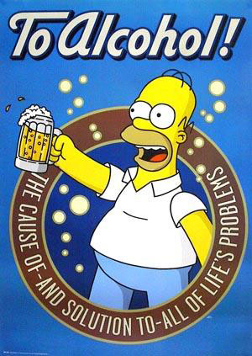
Choosing to abstain from alcohol is perfectly acceptable, what should simply never be tolerated is over consumption, and abuse of alcohol. Drinking moderately is controlled drinking, and sticking to a strict intake for a potential of healthy rewards. This does not mean that you did not drink yesterday, or at all last week, and today you are going to have a couple of extra drinks to make up for what you missed. If you skip one or more days, that’s great, today is a new day and only drink your moderated limit of about two drinks. A strict diet is difficult for many Americans and adding alcohol to any diet can lead to misuse and abuse. Know yourself, know your limitations and avoid or abstain if you are at risk of potential problems. Only conscious, controlled use is encouraged and always only in moderation.
For more information on benefits of alcohol on: Visit www2.potsdam.edu/hansondj/AlcoholAndHealth.html for information on Heart Health, Strokes, Diabetes, Alzheimer's Disease and Other Dementia, Arthritis, Enlarged Prostate, Osteoporosis, Gallbladder Disease, Cancers, and the common cold. I strongly encourage anyone thinking of adding alcohol to their diet for the potential health benefits. To do some serious research and talk with their doctor.
Since I started research for this paper I have conducted my own study of the effects of alcohol in moderation. My diet has not changed other than I now add one to three drinks a day, and I never exceed more than three standard drinks per day. Since adding alcohol to my diet I have noticed a few benefits. Normally before the diet change and after a good workout I became sore and exhausted the next day. This would lead to a complete stop to any exercise program. Now I feel relaxed, energized, and ready to work out again. I have also noticed a mild reduction in my blood pressure. I feel more at ease; I notice a mild reduction of stress, even on days with difficult tests—an increased ability to deal with any of my daily struggles.

Works Cited
"Alcohol and Sperm." A Great Resource For The Causes Of Infertility, Infertility Treatment, And
The Best Ways To Get Pregnant. 2012. Web. 06 Feb. 2012.
"Alcohol Prevention Education." Santa Ana College. 2005. Web. 06 Feb. 2012.
Hanson, Ph.D., David J. "Alcohol And Health." Www2.potsdam.edu. Bitglyph, 2011. Web. 06
Feb. 2012.
Hendrickson, Kirstin. "Alcohol And Conception In Pregnancy | LIVESTRONG.COM."
LIVESTRONG.COM - Lose Weight & Get Fit with Diet, Nutrition & Fitness Tools Demand Media, Inc, 29 Apr. 2011. Web. 06 Feb. 2012.
National Institute of Alcohol Abuse and Alcoholism. "ALCOHOL AND THE DEVELOPING
ADOLESCENT BRAIN." NIAAA_Brain_Fact_Sheet_508.pdf. Web. 06 Feb. 2012.

